PANITIA FIZIK
SEKOLAH – SEKOLAH MENENGAH
WILAYAH PERSEKUTUAN PUTRAJAYA

PERATURAN PERMARKAHAN
PEPERIKSAAN PERCUBAAN
WILAYAH PERSEKUTUAN PUTRAJAYA
TAHUN 2020

SKEMA JAWAPAN PERCUBAAN SEKOLAH – SEKOLAH MENENGAH PUTRAJAYA

KERTAS 1 4531/1

1 | A | 11 | D | 21 | C | 31 | B | 41 | A
2 | C | 12 | A | 22 | D | 32 | C | 42 | C
3 | B | 13 | B | 23 | D | 33 | C | 43 | D
4 | A | 14 | D | 24 | D | 34 | B | 44 | A
5 | D | 15 | C | 25 | B | 35 | A | 45 | A
6 | A | 16 | B | 26 | D | 36 | C | 46 | D9
7 | D | 17 | B | 27 | A | 37 | C | 47 | B
8 | C | 18 | A | 28 | B | 38 | C | 48 | B
9 | C | 19 | C | 29 | B | 39 | B | 49 | B
10 | B | 20 | C | 30 | B | 40 | C | 50 | A

FIZIK KERTAS 2 4531/2
SECTION A
BAHAGIAN A
SOALAN 1

No |  | Mark Scheme | Sub Mark | Total Mark
1(a) |  | State the meaning of velocity correctly  Rate of change of displacement | 1 | 1
(b) | (i) | Tick the correct box  √ Zero acceleration | 1 | 3
 | (ii) | Show the correct substation  s = ¹ (8+4) (2.0)  2  Answer with correct unit  12.0 m | 1  1
 |  | TOTAL |  | 4

SOALAN 2

2 (a) | Diode  Diod | 1
(b) | Convert alternating current to direct current / allow current to flow in one direction .  Menukarkan arus ulang alik kepada arus terus / membenarkan arus mengalir satu arah sahaja. | 1
(c) | 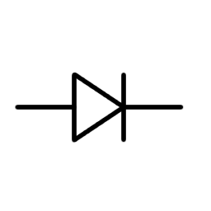 | 1
(d) | 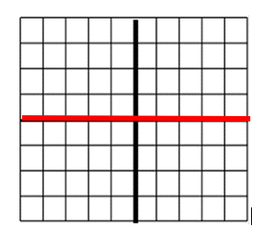 | 1
( e) | Reverse bias not allowed current to flow on it / no current flow  Pincang sonsang tidak membenarkan arus mengalir / tiada pengaliran arus. | 1
TOTAL |  | 5

SOALAN 3

3 (a) | Time for activity/ mass / number of an atom of radioactive to become half.  Masa untuk aktiviti / jisim / bilangan sesuatu radioaktif menjadi separuh. | 1
(b)(i) | Right kidney  Ginjal kiri | 1
(b)(ii) | Activity of radioactive not reduced after 20 minutes  Aktiviti radioaktif tidak berkurang selepas 20 minit | 1
(c)(i) | 1600 🡺800🡺400 🡺200🡺100 // 4 half-life  4 x 8 II 32 days | 1  1
(c)(ii) | 1 🡺½ 🡺 ¼ 🡺 ⅛ // 3 x 8 //24 days | 1
 | TOTAL | 6

SOALAN 4

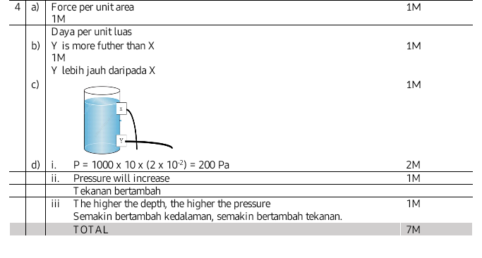

SOALAN 5
5 | (a) | Kuantiti haba yang diperlukan oleh suatu bahan berjisim 1 kg untuk menaikkan suhu  1 °C | 1 | 1
 | (b) (i) | Perubahan suhu bagi Rajah 5.2 lebih besar dari Rajah 5.1// sebaliknya | 1 | 4
 | (ii) | Muatan haba tentu pada Rajah 5.1 lebih besar dari Rajah 5.2 // sebaliknya | 1
 | (iii) | Sama | 1
 | (iv) | Sama | 1
 | (c) | Perubahan suhu berkadar songsang dengan muatan haba tentu //  Muatan haba tentu bertambah, perubahan suhu berkurang | 1 | 1
 | (d) | Daratan mempunyai muatan haba tentu yang lebih kecil dari lautan | 1  Mana-mana satu | 2
 |  | Pada siang hari, daratan lebih cepat panas dari lautan // Peningkatan suhu di darat lebih tinggi dari laut
 |  | Udara panas di darat akan naik ke atas // Udara panas menyebabkan kawasan bertekanan rendah | 1  Mana-mana satu
 |  | Udara sejuk dari lautan bergerak ke darat // Perolakan udara berlaku
JUMLAH |  |  |  | 8

SOALAN 6
( a ) | Potential Difference is the work done by 1 C of charge form 1 point to another point.  Kerja yang dilakukan oleh 1 C cas elektrik dari satu titik ke suatu titik. | 1
( b ) | Bulb B light up  Mentol B menyala | 1
( c ) | Circuit arrange in parallel circuit / Parallel circuit allow current to flow in many direction .  Litar selari / litar selari membenarkan arus mengalir banyak arah. | 1
( d ) ( i ) | Same  Sama | 1
(ii ) | 6.1 > 6.2 | 1
( iii ) | 6.1 in series connection , 6.2 in parallel connection  6.1 disambung secara sesiri , 6.2 disambung secara selari. | 1
( e ) | If circuit in series circuit, the effective resistance will increase / vice versa  Jika sambungan secara sesiri, rintangan berkesan bertambah | 1
( f ) | If battery was connect in series circuit, so the EMF higher.  Jika bateri disambung secara sesiri, maka DGE adalah besar. | 1
 | TOTAL | 8

SOALAN 7
Section | Answer | Mark | Note
(a) | Interference  Interferens | 1
(b) | Increases  meningkat | 1
(c)(i) | Oscillates up and down with a large amplitude  Berayun ke atas dan ke bawah dengan amplitude yang besar | 1
(c)(ii) | Constructive interference occurs at P  Interferens membina berlaku di P | 1
(d) | Distance increases  Jarak berkurang  Speed of the waves increase  Laju gelombang meningkat  Wavelength is longer  Panjang gelombang meningkat | 1  1  1
(e)(i) | In front of the microphone  Di hadapan mikrofon  Avoid disturbance // to prevent the sound from speakers being amplified again by the microphones  Mengelakkan gangguan // menghalang bunyi daripada pembesar suara dikuatkan semula oleh mikrofon | 1  1
(e)(ii) | Further distance between the speakers  Jauh dari satu sama lain  So that positions of constructive and destructive interference are closer together until they are hardly noticeable.  Kedudukan interferens membina dan memusnah dekat antara satu sama lain sehingga sukar didengari | 1  1
 | TOTAL | 11

SOALAN 8
8 | a | The bending of light when it enter into different densities of different medium. |  | 1M
 |  | Pembengkokkan cahaya yang merambat dalam dua ketumpatan medium berbeza.
 | b | P = $\frac{1}{f}$
 |  | i. | P = $\frac{1}{5 x {10}^{-2} }$ = 20 D | 1M
 |  | ii. | $\frac{1}{f}= \frac{1}{u}+ \frac{1}{v}$  $\frac{1}{5}= \frac{1}{15}+ \frac{1}{v}$  $v= \frac{15}{2}$ =7.5 cm | 2M
 | c |  | 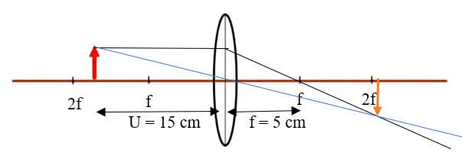 | 3M
 | d | i | f_{o} < U_{o} < 2f_{o} | 2M
 |  |  | Produced real//inverted//magnitfied image
 |  |  | Menghasilkan imej yang nyata//sonsang// besar
 |  | ii | d > (f_{o} + f_{e} ) | 2M
 |  |  | Image that formed by the objective lens is positioned at a distance less than f_{e}.
 |  |  | Imej pada kanta objektif akan terbentuk di hadapan f_{e}.
 |  | iii | L | 1M
TOTAL |  |  |  | 12M

BAHAGIAN B
SOALAN 9
9 | (a)  (b)  (c)  (d) | (i)  (ii) | Density is defined as mass per unit volume.  Ketumpatan ditakrifkan sebagai jisim per unit isi padu  The height of balloon in Diagram 9.1 is lower than the height of balloon in Diagram 9.2.  Ketinggian belon di Rajah 9.1 adalah lebih rendah daripada ketinggian belon di Rajah 9.2  The density of air in Diagram 9.1 is lower than the density of air in Diagram 9.2.  Ketumpatan udara di luar belon di Rajah 9.1 adalah kurang daripada ketumpatan udara di luar belon di Rajah 9.2.  The temperature of air outside the balloon in Diagram 9.1 is higher than the temperature of air outside the balloon in Diagram 9.2  Suhu udara di luar belon di Rajah 9.1 adalah lebih tinggi daripada suhu udara di luar belon di Rajah 9.2.  When the temperature of the air outside the balloon is high, the density of air is low. The higher the temperature, the smaller the buoyant force.  Apabila suhu udara di luar belon itu adalah tinggi, ketumpatan udara adalah rendah. Semakin tinggi suhu,semakin kecil daya apungan.  The density of gas in the balloon is smaller than the density of air. Hence, the weight of the balloon is less than the buoyant force of the air.The greater buoyant force pushes the balloon to go up.  Ketumpatan gas dalam belon adalah lebih kecil daripada ketumpatan udara. Maka, berat belon adalah kurang daripada daya apungan udara. Daya apungan yang lebih besar itu menolak belon ke atas.  Characteristics Ciri Reason Sebab  Large balloon Belon besar To produce a higher buoyant force Untuk menghasilkan daya keapungan yang lebih besar  Elastic/Strong/light/can be stretched easily/water proof Kenyal/kuat/ringan/boleh diregangkan dengan mudah/kalis air Enable the balloon to withstand pressure /and it is lasting and durable. /Water and air cannot enter balloon through its wall. Membolehkan belon itu untuk menahan tekanan tinggi /dan belon itu tahan lama dan tidak mudah pecah. /Air dan udara tidak boleh meresap memasuki belon.  Use more burners Gunakan bahan pembakar yang banyak To produce a bigger flames// Heat up the gas in the balloon faster. Untuk menghasilkan api yang lebih besar//memanaskan gas di dalam belon dengan lebih cepat.  High temperature of the air in the balloon Suhu udara yang tinggi dalam belon To reduce density and weight of the air in the balloon. Untuk mengurangkan ketumpatan dan berat udara di dalam belon.  Early morning// Late evening Awal pagi // Lewat petang High density of air surrounding/ Greater upthrust force Ketumpatan udara disekeliling tinggi // Daya tujah ke atas lebih tinggi | 1  1  1  1  2  4  10 | 1  5  4  10  20

SOALAN 10
10 | (a)  (b)  (c)  (d)  (e) | (i)  (ii) | To increase or decreasing the output of AC current  Meningkatkan atau menurunkan voltan bagi arus ulang alik  - 10.1 > 10.2  - 10.2 < 10.1  - 10.2 > 10.1  The higher, the higher  Semakin bertambah , semakin bertambah  If the number of secondary coil increase, the transfomers is step up / vice versa  Jika bil lilitan pada gegelung sekunder meningkat, maka transformer injak naik  - Use a semicircular magnet because it have a radial magnetic fields.  Menggunakan magnet semi bulatan / melengkung untuk menghasilkan medan magnet jejarian.  - Use a strong magnetic fields to produce stronger magnetic fields.  Gunakan medan magnet yang kuat untuk menghasilkan medan magnet yang kuat.  - Increase the number of turn of coil to increasing the rotation.  Meningkatkan bilangan lilitan gegelung untuk meningkatkan putaran motor  - Increase the current to produced a strong magnetic fields  Meningkatkan arus untuk menghasilkan medan magnet yang kuat.  Characteristics Ciri Reason Sebab  Stailess steel Keluli Long lasting Tahan lama  High tower Menara tinggi Easy to do maintenance Mudah unyuk penyelenggaraan  Thick besar Reduce a resistance / prevent energy loss to the surrounding. Mengurangkan rintangan / mengelakkan tenaga yang hilang keperdekitaran.  Alluminium Low resistance / low cost Rintangan rendah / kos rendah  Porselin ball Penyokong porselin Prevent current from leakage. Mengelakkan kebocoran arus | 1  1  1  1  1  1  1 | 1  3  2  4  10  20

BAHAGIAN C
SOALAN 11
11 | (a) | The incident angle when the refractive angle is 90 ˚.  Sudut tuju apabila sudut biasan ialah 90 ˚ | 1 | 1
 | (b) | - A prism periscope using two block prism to allowed total internal reflection  Teleskop prisma menggunakan dua blok prism untuk membenarkan pantulan dalm penuh berlaku.  - Arrangement of prism 45-90-45 to make sure twist total internal reflection.  Susunan prisma kaca 45-90-45 untuk memastikan pantulan dalam penuh berlaku dua kali.  - Arrangement prism 45-90-45 bellow to produce upright final image  Susunan prisma adalah 45-90-45 untuk menghasilkan imej akhir yang tegak  - Install a eyes and objective lense to produce clear and shrap image.  Menambah kanta objektif dan kanta mata untuk menghasilkan imej yang jelas dan tajam. | 1  1  1  1 | 4
 | (c) | 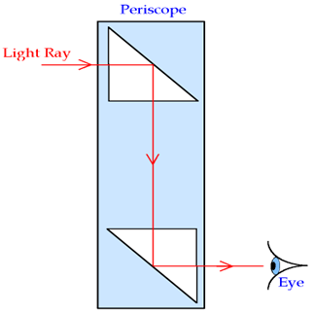 | 1  1  1 | 3
 | (d) | n = $\frac{1}{sinsin c }$  n = $\frac{1}{sinsin 42 }$ = 1.63 | 1  1 | 2
 | (e) | Aspek – aspek Alasan  Thin Nipis Have a longest focal length Mempunyai Panjang fokus yg panjang  Pelarasan d = ( f_{o} + f_{e} ) To form image at infinity . Membnetuk imej akhir pada titik infiniti  f_{e/m} < f_{o} Produced virtual, inverted image Menghasilkan imej maya dan sonsang  Covex Cembung Produced many image at any distance object. Membentuk pelbagai imej pada mana – mana kedudukan objek.  Telscope R | 1+1  1+1  1+1  1+1  1+1 | 10
TOTAL |  |  |  | 20

SOALAN 12
12 | a) | Longitudinal waves  Gelombang membujur | 1 | 1
 | b) | - Build at a cape kerana air lebih tenang  Dibina dikawasan teluk kerana air lebih tenang.  - Built with a high retaining wall with a small opening.  Dibina dengan tembok penahan yang tinggi dengan bukaan kecil.  - The opening gap will reduce an energy  Bukaan kecil dibina untuk mengurangkan tenaga.  - Big bottom of retaining wall to withstand a high pressure.  Tembok penahan dengan size tapak yang besar bagi mengatasi tekanan yang besar. | 1  1  1  1 | 4
 | c) (i) | 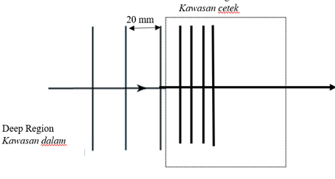 | 1  1 | 2
 | (ii) | f = $\frac{v}{λ}$  = $\frac{30}{20 x {10}^{-3}}$ = 1500 Hz | 1  1 | 2
 | (iii) | 1500 Hz | 1 | 1
 | (d) | Aspek Alasan  Microwaves mikro Can penetrate at atmosphere. Menembusi atmosfera  High frequencies Frekuensi tinggi Have a high energy Tenaga yang tinggi  Big diameter Diameter besar Can reflect and receives more signal. Menerima dan memantul isyarat yang banyak.  High Tinggi Reduce difraction effect. Mengurangkan kesan pembelauan. | 1+1  1+1  1+1  1+1
 |  | X is choosen | 1+1 | 10
TOTAL |  |  | 20

KERTAS 3 4531/3
NO  KERTAS 3 SET A PERCUBAAN WP PUTRAJAYA 2020 | KRITERIA PEMARKAHAN | MARKAH
 |  | SUB | TOTAL
1(a) (i) | Sudut tuju / i | 1 | 1
(ii) | Sudut biasan / r | 1 | 1
(iii) | Ketumpatan bongkah kaca // indeks biasan bongkah kaca | 1 | 1
(b) (i)  (ii)  (iii) | Rajah 1.2 : 11°  Rajah 1.3 : 20°  Rajah 1.4 : 29°  Rajah 1.5 : 36°  Rajah 1.6 : 41°  Nota : 1. semua betul ( unit ) – 2 markah  2. 4 betul sahaja – 1 markah  3. konsisten  Rajah 1.2 : 0.26  Rajah 1.3 : 0.50  Rajah 1.4 : 0.71  Rajah 1.5 : 0.87  Rajah 1.6 : 0.97  Nota : 1. semua betul ( tanpa unit ) – 1 markah  2. konsisten kepada 2 - 4 tempat perpuluhan  Rajah 1.2 : 0.19  Rajah 1.3 : 0.34  Rajah 1.4 : 0.48  Rajah 1.5 : 0.59  Rajah 1.6 : 0.66  Nota : 1. semua betul ( tanpa unit ) – 1 markah  2. konsisten kepada 2 - 4 tempat perpuluhan | 1  1  1  1 | 1  1  1  1
(c) | Menjadualkan nilai i, r, sin i dan sin r dengan betul  i ( ⁰ ) r ( ⁰ ) sin i sin r  15 11 0.26 0.19  30 20 0.50 0.34  45 29 0.71 0.48  60 36 0.87 0.59  75 41 0.97 0.66  1. Semua nama atau simbol bagi i, r, sin i dan sin r adalah  betul  2. Semua unit bagi i, r, sin i dan sin r adalah betul (jika ada)  3. Semua nilai i, r, sin i dan sin r adalah konsisten | 1  1  1 | 3
(d) | Melukis graf sin r melawan sin i  Bagi tanda (✔) berdasarkan kenyataan dibawah :  A ⚫ sin r pada paksi y, sin i pada paksi x  B ⚫ Unit betul pada kedua-dua paksi ( sekira ada )  C ⚫ Skala seragam  D ⚫ 5 titik di plot dengan betul  [Nota : 4 plot yang betul ✔]  E ⚫ Garis lurus, seimbang dan licin  F ⚫ Saiz graf 5 x 4  ( Petak besar : 2 cm x 2 cm)  Nombor ✔ Markah  7 ✔ 5  5 – 6 ✔ 4  3 – 4 ✔ 3  2 ✔ 2  1 ✔ 1 | ✔₁  ✔₂  ✔₃  ✔_{4 & 5}  ✔₆  ✔₇  7 | 5
(e) | Sin r berkadar secara langsung dengan Sin i  @  Sin r bertambah secara linear dengan Sin i | 1 | 1
 | Total | 16 | 16

NO |  | MARKING SCHEME | MARK
2 | a.i | State the relationship between f and 1/x correctly | 1
 |  | directly proportional / berkadar terus
 | a.ii | When h = 0.30m ;
 |  | Extrapolate the graf | 1
 |  | the horizontal/vertical line to the axis | 1
 |  | a=1.5 ms⁻² | 1
 | a.iii | Calculate the gradient of the graph and state the value within the acceptable range  Show the triangle with an acceptable size ( 5 x 4 squares of 2 cm)  Substitute correctly ( according to the candidate’s graph)  State the correct value of the gradient with unit  m = 5 s⁻²
 |  |  | 1
 |  |  | 1
 |  |  | 1
 | b | _{m=g/l}  _{g=ml}  =5 x 2  g=10 ms-2 | 1  1
 | c | a=10/1.5 x 0.10  =0.67ms⁻²
 |  |  | 1
 |  |  | 1
 | d | State ONE correct precaution so as to produce an accurate result of the experiment  M1 The position of the eyes is perpendicular to scale readings of meter ruler to avoid parallax error //  Permukaan landasan licin untuk mengurangkan geseran.
 |  |  | 1
Total |  |  | 12

Question | Mark SAkcheme | Total mark
3(a) | State a suitable inference  Refracted angle in influenced by incidence angle | 1
(b) | Statet a relevant hypothesis  The higher the incidence angle, the higher refracted angle | 1
(c)(i) | State the aim of the experiment  To investigate the relationship between the incidence angle, the refracted angle | 1
(ii) | a) manipulated :the incidence angle  b) responding : the refracted angle  c) fixed :refracted index, n / density of glass block | 1  1  1
(iii) |  | 1
(iv) | 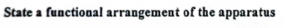  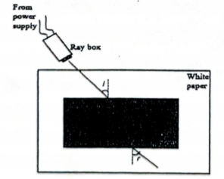 | 1
(v) | The eksperiment was set up as in the diagram above. Switch on the power supply. The ray box was adjusted until the incidence angle is 10º.  Refracted angle was measured and recorded.  Experiment was repeated by using angle of 20º, 30º, 40º, 50º. | 1  1  1
(vi) | State how the data is tabulated  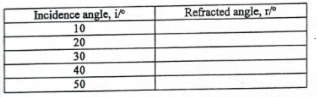 | 1
(vii) | State how the data is analysed  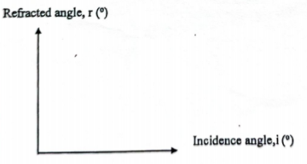 | 1

4  (a) | 1 | State a suitable inference  The number of turns of wire in the secondary coil affects the output voltage
(b) | 1 | State a relevant hypothesis  The greater the number of turns of wire in the secondary coil, the greater the output voltage
(c) | 1 | State the aim of experiment  To investigate the relationship between number of turns of wire in the secondary coil and the output voltage
 | 1 | State the manipulated variable and the responding variable  Manipulated : number of turns of wire in secondary coil, N  Responding : output voltage, V
 | 1 | State ONE variable that kept constant  The number of turns of wire in the primary coil
 | 1 | Complete list of apparatus and materials  Thermometer, capillary tube, concentrated sulphuric acid, half metre rule, beaker, water, stirrer, Bunsen burner, tripod stand
 | 1 | Arrangement of apparatus :  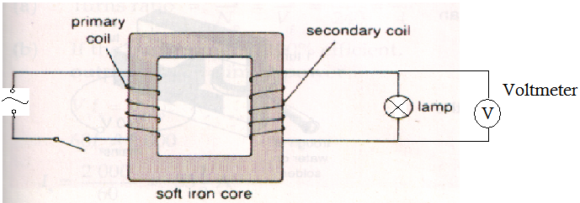
 | 1  1  1 | State the method of controlling the manipulated variable  1. The set up of the apparatus is as shown in figure above.  2. 100 turns of wire is wound on the secondary coil of a transformer.  State the method of measuring the responding variable  3. The switch is on and the output voltage is measured by using a voltmeter.  Repeat the experiment at least 4 times  The experiment is repeated by winding the wire on secondary coil with 200 turns, 300 turns, 400 turns and 500 turns.
 | 1 | Tabulation of data:  Number of turns of wire in secondary coil, N Output voltage, V / V
 | 1 | Analyse the data .  Voltage  No. of turns
Total marks
12

